Goal number change: northern most goal 201 change to 201A (348134 / 3898117
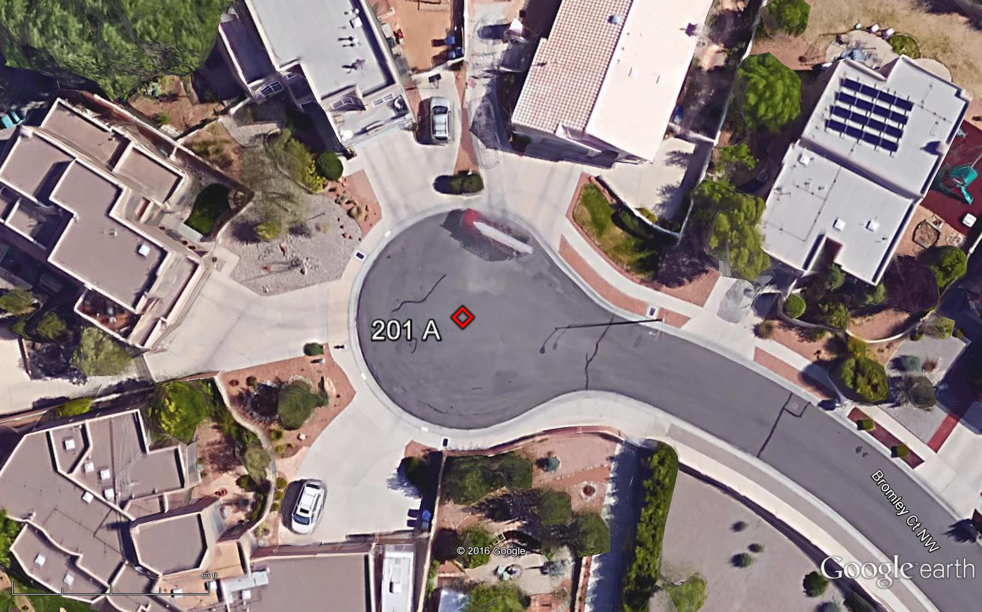

Rule II.1 Contest area: Change west gridline from 4100 to 3800
Rule II.9 Air Law: Entire contest area includes surface up to 9400 MSL
Rule II.17 Details for the use of GPS-loggers: At no time is the competitor allowed to modify the logger’s critical settings (see 6.6.3) or interfere with its operation other than specifically instructed by the Director.

Hard Target Coordinate change: Target 4801 A change to 348263 / 3901772
Hard Target Coordinate change: Target 5794 change to 357050 / 3894560

